> setwd("C:/Users/91958/Desktop")

> linear_model<-read.csv("LM.csv",header = TRUE)

> linear_model

Hours Scores

1 2.5 21

2 5.1 47

3 3.2 27

4 8.5 75

5 3.5 30

6 1.5 20

7 9.2 88

8 5.5 60

9 8.3 81

10 2.7 25

11 7.7 85

12 5.9 62

13 4.5 41

14 3.3 42

15 1.1 17

16 8.9 95

17 2.5 30

18 1.9 24

19 6.1 67

20 7.4 69

21 2.7 30

22 4.8 54

23 3.8 35

24 6.9 76

25 7.8 86

> View(linear_model)

> Hours<-linear_model$Hours

> Scores<-linear_model$Scores

> plot(Hours,Scores)

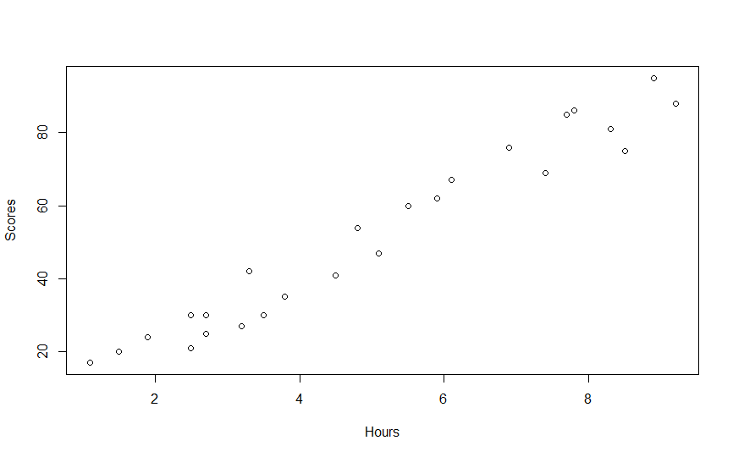

> plot(Hours,Scores,pch=16,cex=1,col='blue',main='Hours v/s Scores',xlab = 'Hours',ylab = 'Scores')

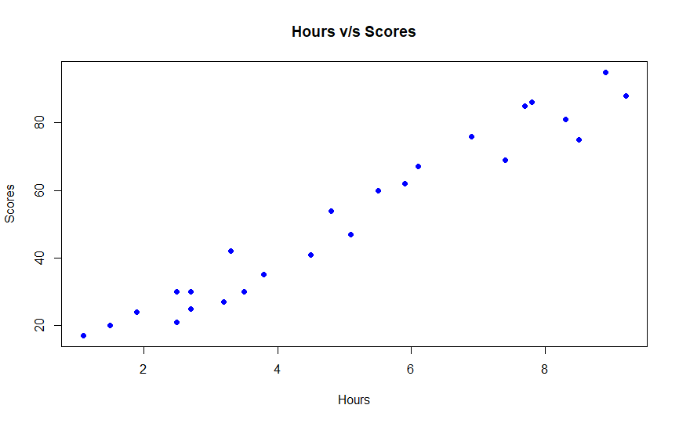

> LM<-lm(Scores~Hours)

> LM

Call:

lm(formula = Scores ~ Hours)

Coefficients:

(Intercept) Hours

2.484 9.776

> summary(LM)

Call:

lm(formula = Scores ~ Hours)

Residuals:

Min 1Q Median 3Q Max

-10.578 -5.340 1.839 4.593 7.265

Coefficients:

Estimate Std. Error t value Pr(>|t|)

(Intercept) 2.4837 2.5317 0.981 0.337

Hours 9.7758 0.4529 21.583 <2e-16 ***

---

Signif. codes: 0 ‘***’ 0.001 ‘**’ 0.01 ‘*’ 0.05 ‘.’ 0.1 ‘ ’ 1

Residual standard error: 5.603 on 23 degrees of freedom

Multiple R-squared: 0.9529, Adjusted R-squared: 0.9509

F-statistic: 465.8 on 1 and 23 DF, p-value: < 2.2e-16

> abline(LM)

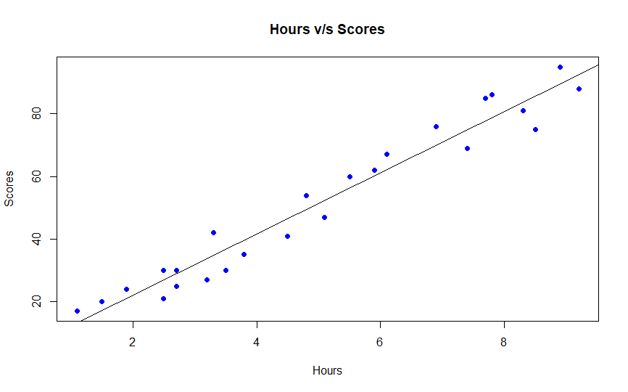

> coef(LM)

(Intercept) Hours

2.483673 9.775803

> #What will be the predicted score if a student studies for 9.25 hours a day?

> #y=b1+b2x

> score<-data.frame(Hours=9.25)

> predict(LM,score)

1

92.90985